Pandas profiling
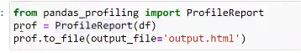
This is mainly us for the sake of converting all the analysis of the whole pandas dataframe.
So that doing analyisis step by steps is stopped so that we can make analysis proper.

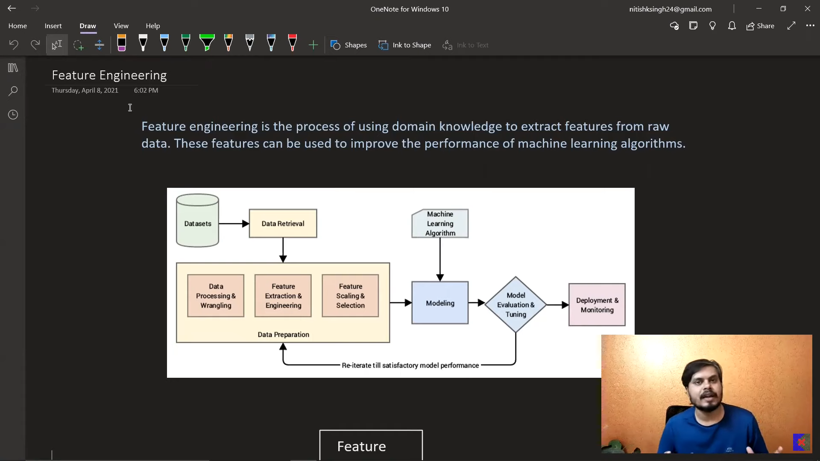
Giving good data to the model is very important, to get the great output.

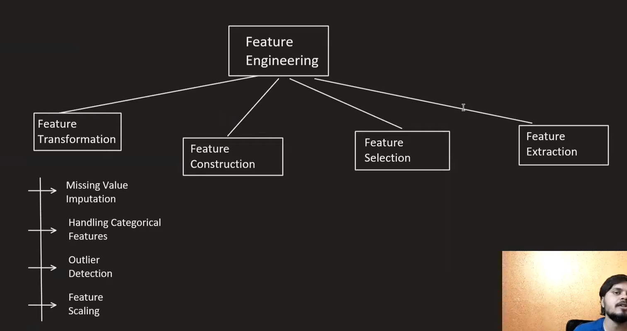

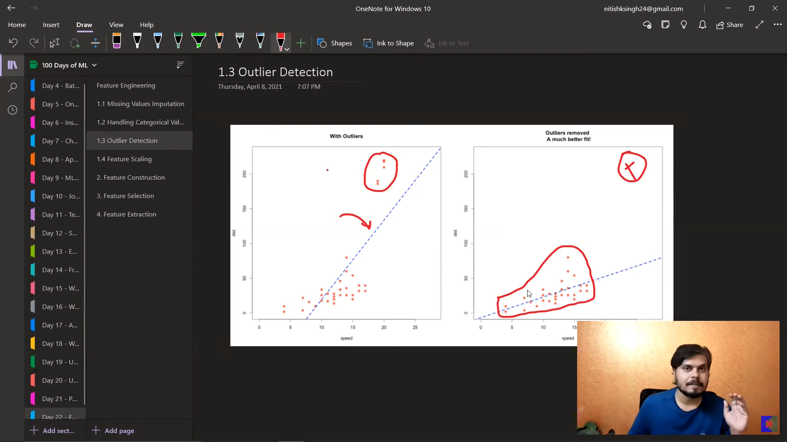
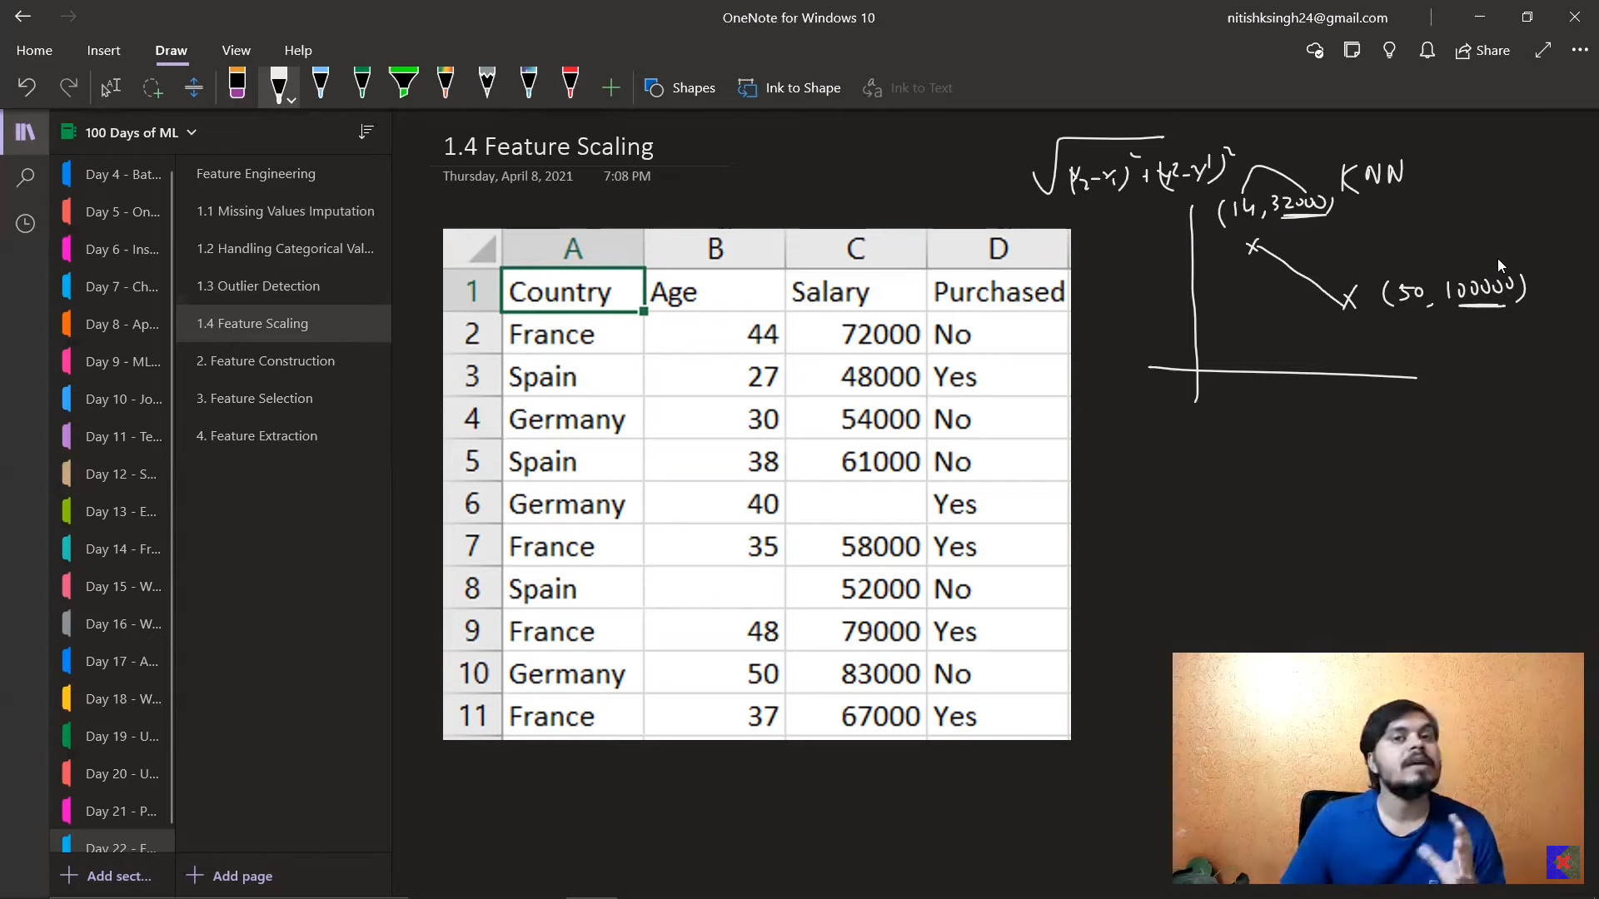
Suppose if you keep the knn for age vs Salary, salary is more dominant over the normal.

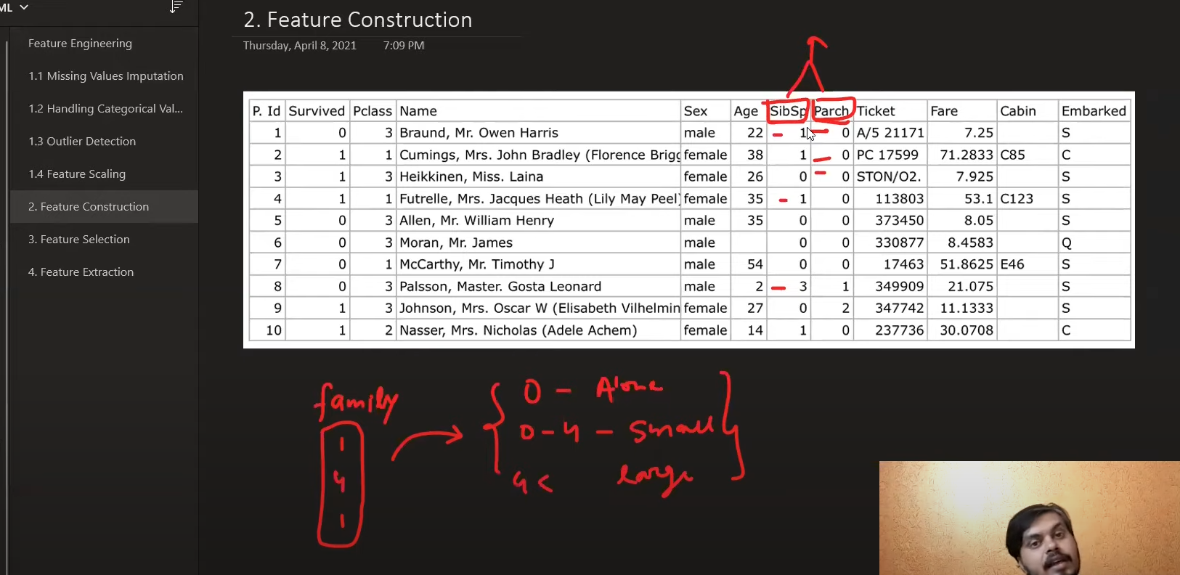
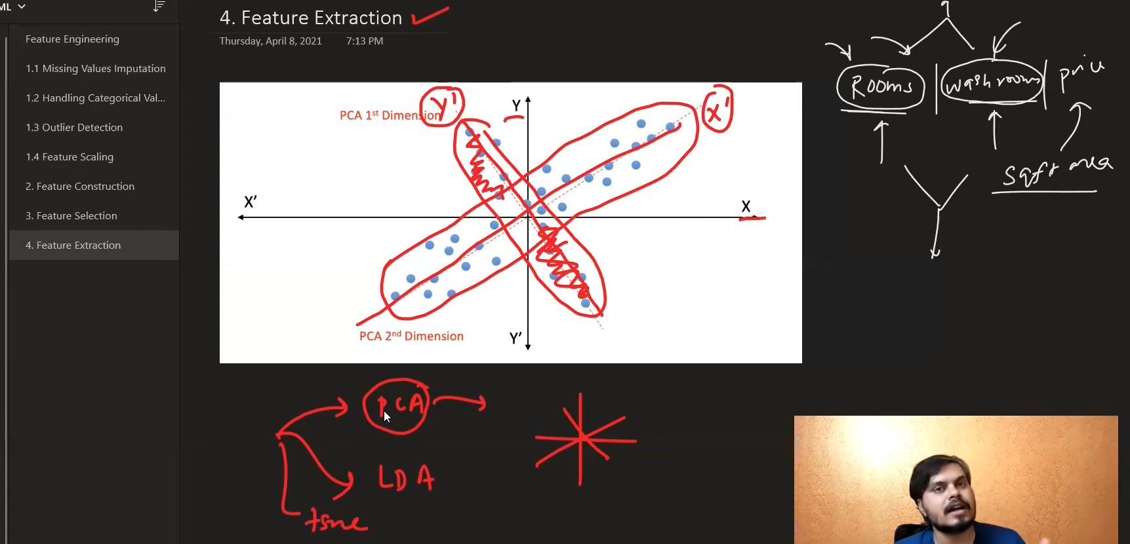

This feature scaling to be given just before passing data to the ML algorithm. But this should not be done before other mechanism like Imputing etc
KNN uses the distance between the 2.
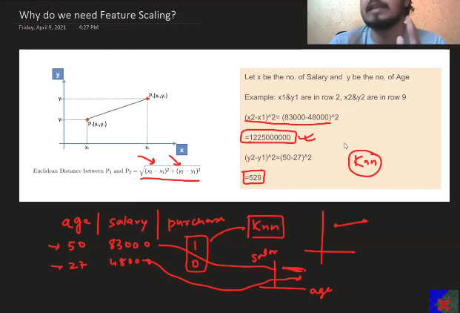
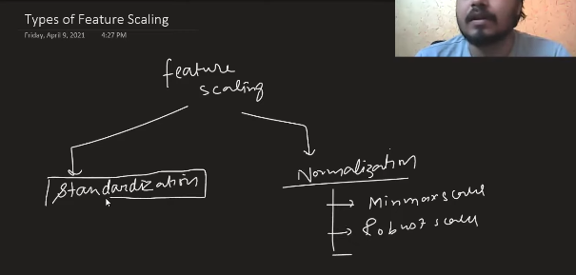
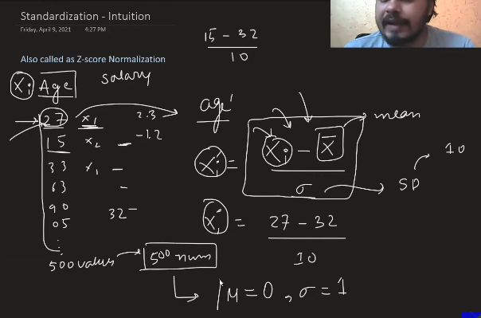
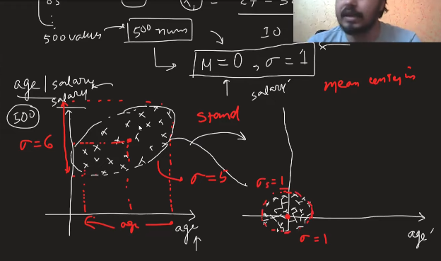
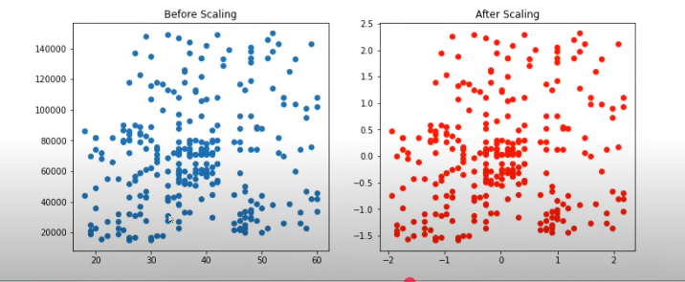
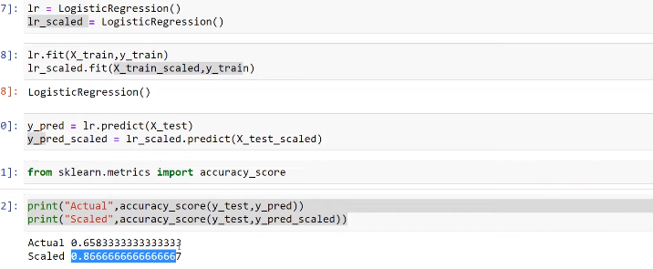
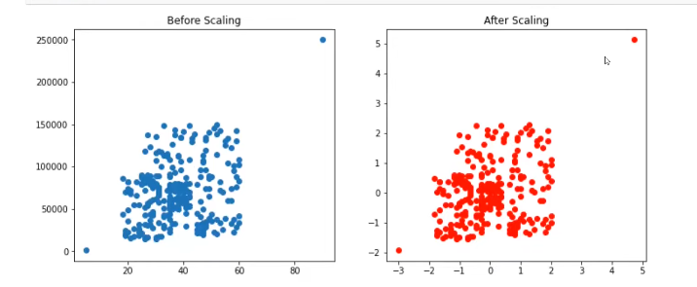
Even after scalng the behaiour of the data remains the same, evn for outliers.
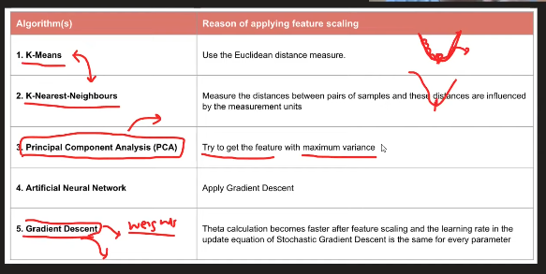
Standard Normalisation is must.

Here the standard normalisation is need not needed. Since it does not matter, whether to say 100> 99, 1>0.99, bot relies on yes or no.

Distance based or direction based algo(Outliers): Standard scaling matters, because this will not affect the relative distance because of the outliers. But when coming to the min-max scalers, the one which is having the highest will be afecting the lowest points, this will affect the whole. This matters.
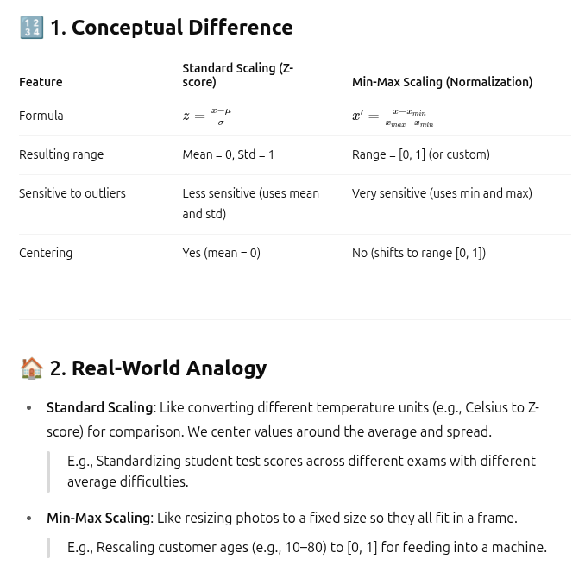
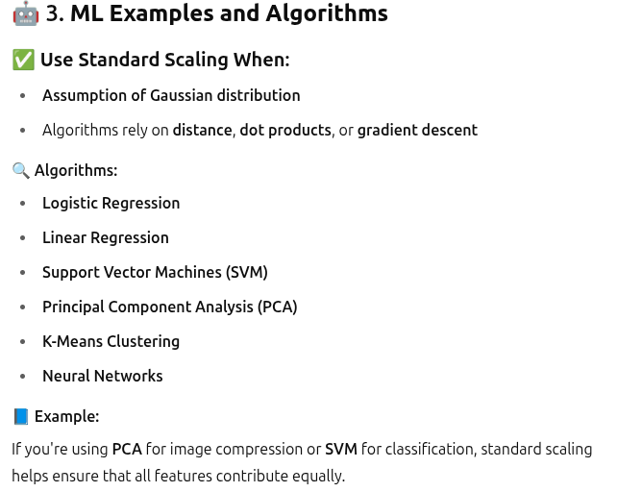

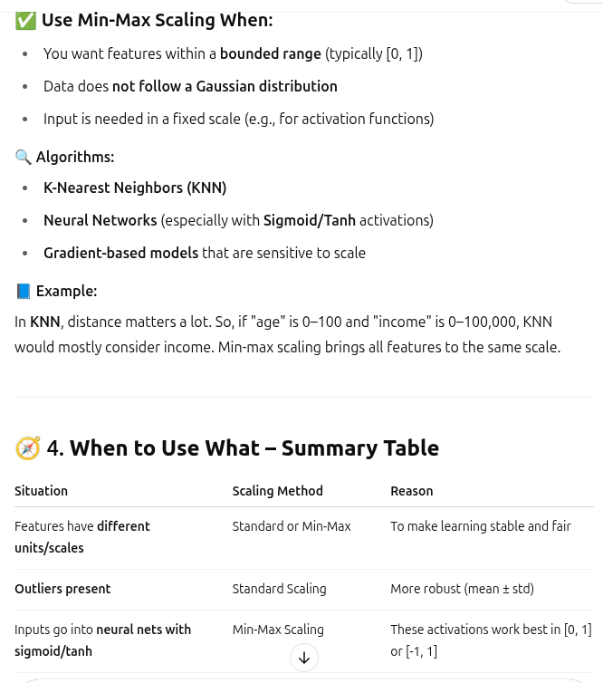

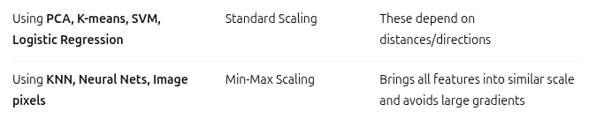

NORMALISATION

Instead if keeping g, kg, m/sec, remove all the units and scale it to the same level, based on that, start giving the input to the ML algo.

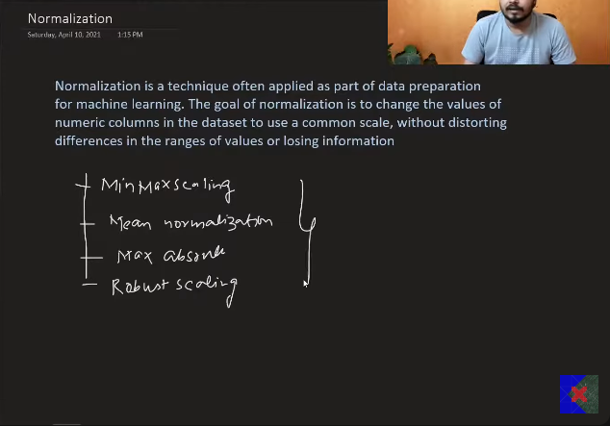
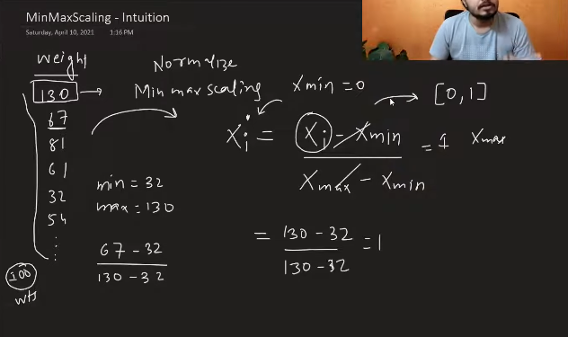
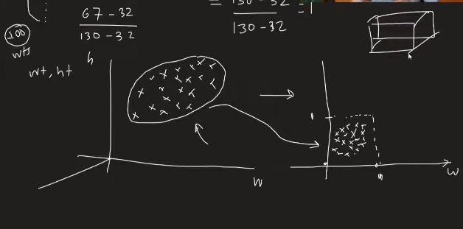
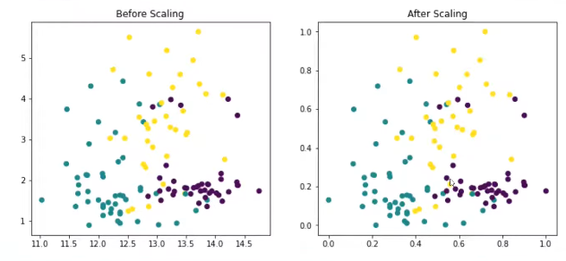
The data formed will be remaining the same almost.
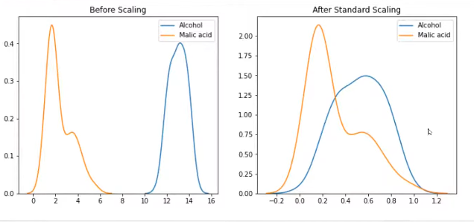
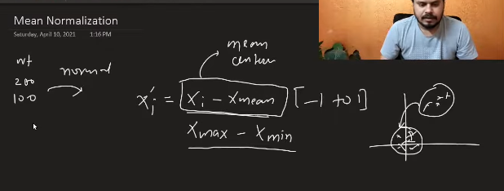
This kind of scaling is useful when we need the centered data. But instead of standard scalers are used.
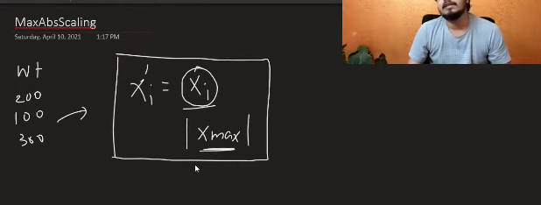
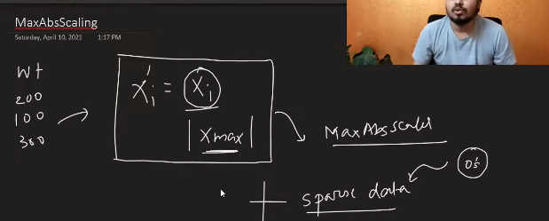
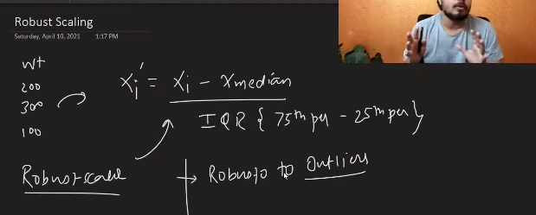
Scaling is not required in DT
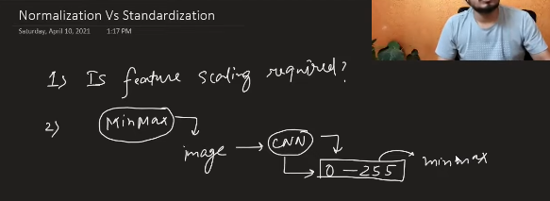
Most of the times Standardisation is used.

Min- Max is used maximmaly when we know what is minimum and what is amximum by default in the dataset. Image processing. (0-255).
Do not know which to use – Use standard scaler. Sparse- Max Absolute Scaling, Outliers - Robust scaling.

ENCODING CATEGORICAL

Nominal – There are statenames we cannot say , one is bigger than the other or not. – One hot ecoding

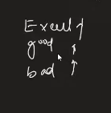
This is ordinal data – orinal ecoding
Label encoding = ordinal encoding +extra

Label encoding is especially made for the output column(Y), X make the ordinal encoding.
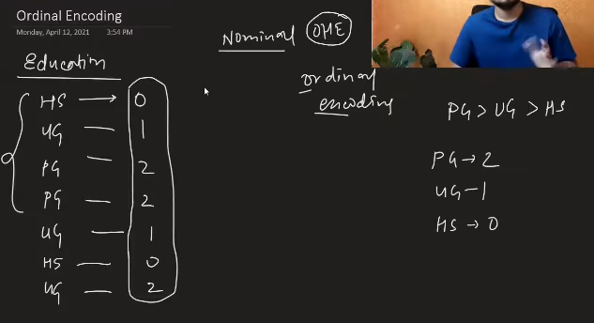
To this ordinal encoding you must give the input regarding the order.
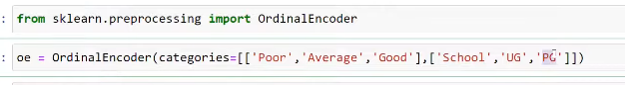
If these values are not given then by deafult rando values are given as input directly.

ONE HOT ENCODING

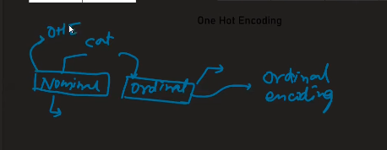
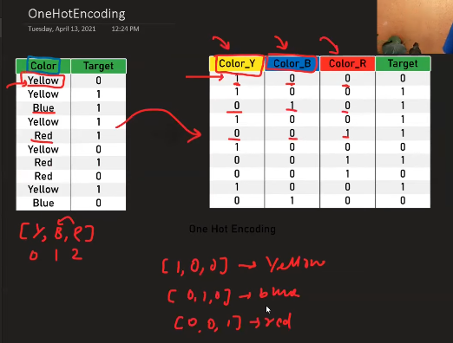
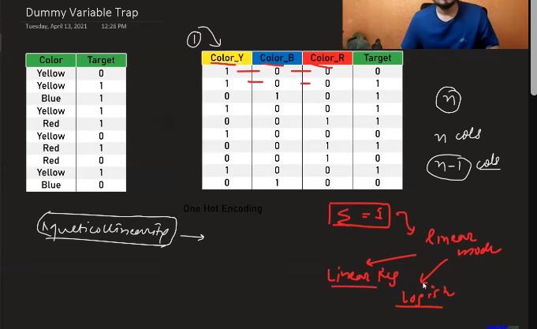
Dummy variable Trap:
All the columns under X is considered to be independent, But if you sum up all the columns which are to be coming under the onehot encoding then it will result in 1 as output.
So to prevent from it, we have to drop any one of the column, but it will result in proper even afetr dropping the column. This is called as the dummy variable trap.

This can be done using the encoded_df = pd.get_dummies(df)
(mention the column names). This is to be done on the nominal columns.

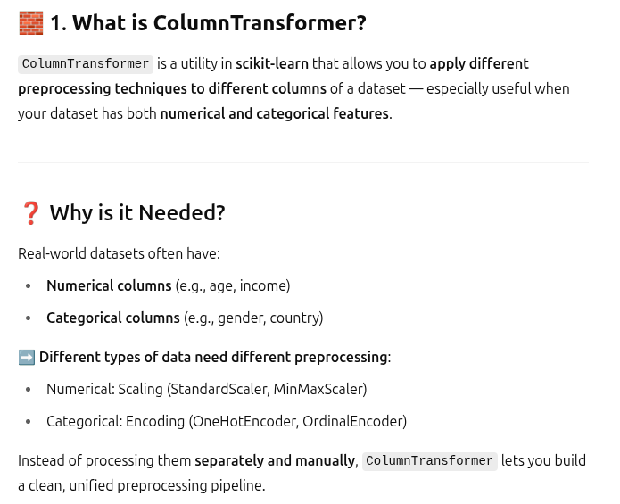

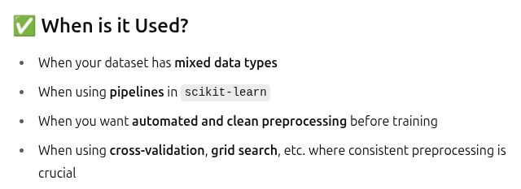
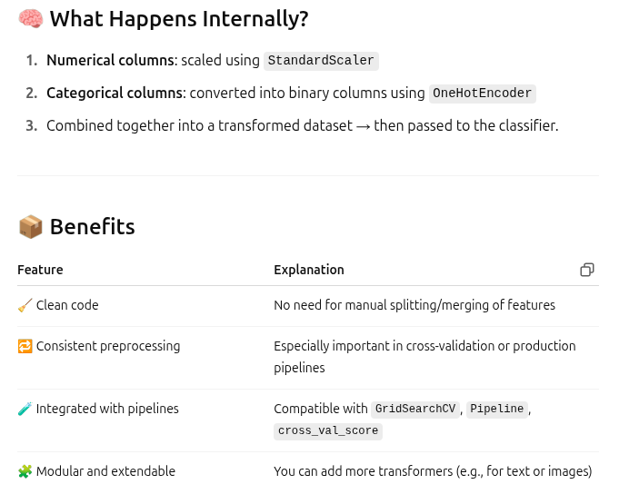

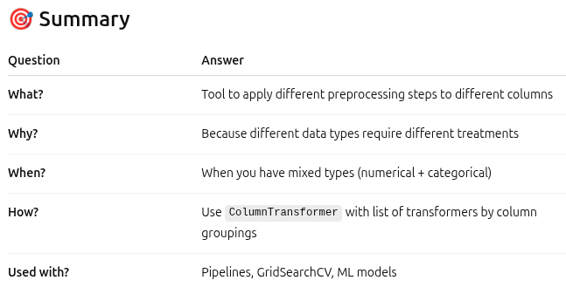

PIPELINE

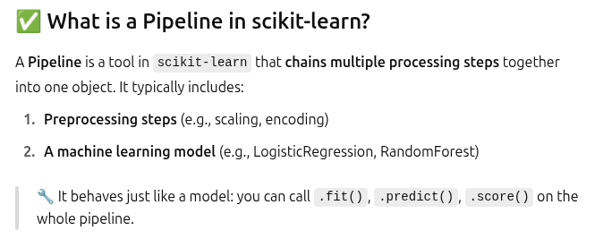

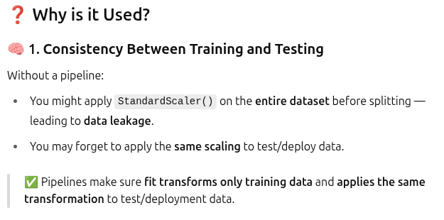
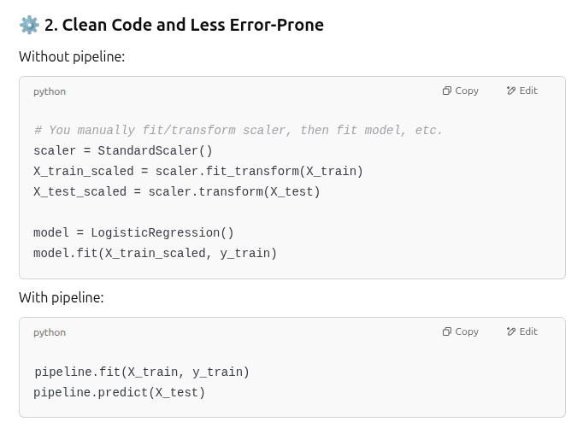

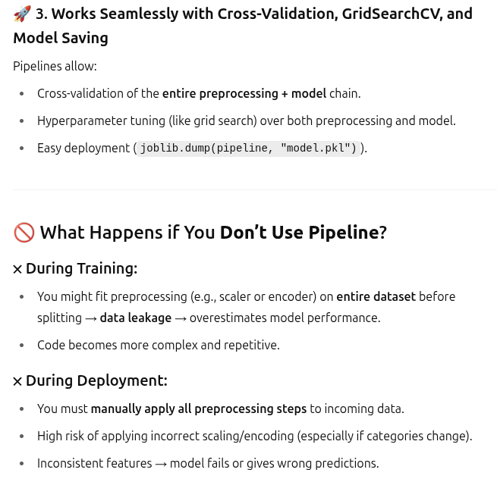

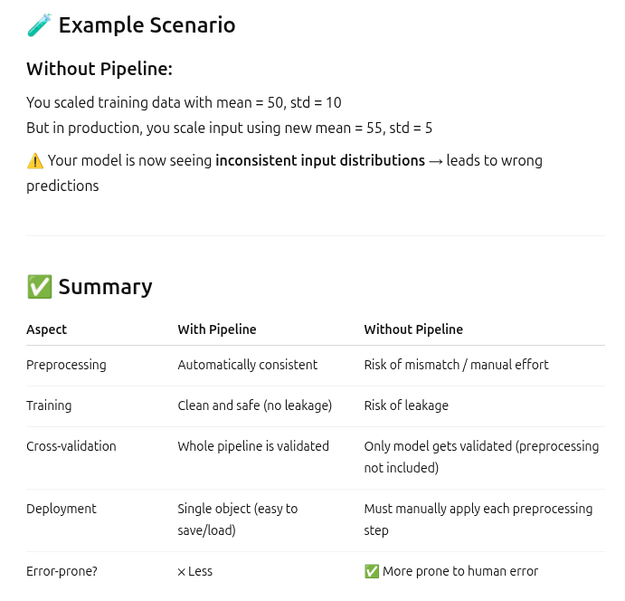

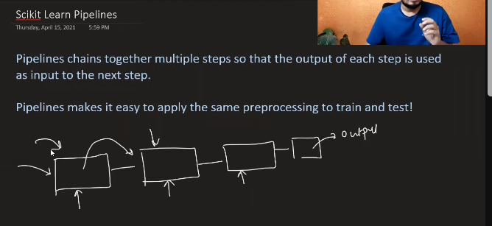

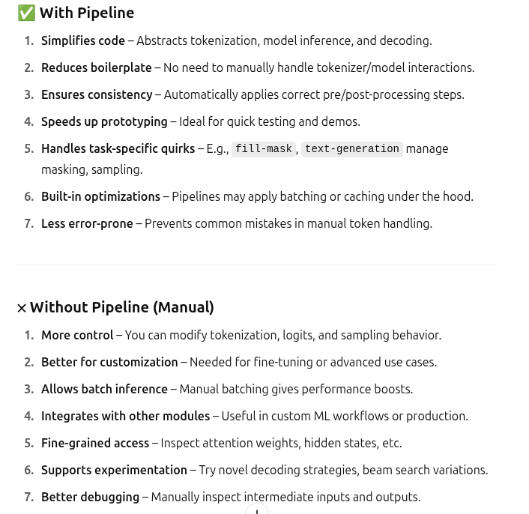

Data Transformers
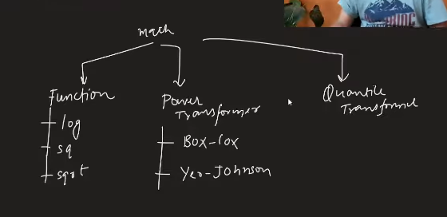

FUNCTION TRANSFORMER

Bringing the data to normal distribution to enhance the performance of the model.
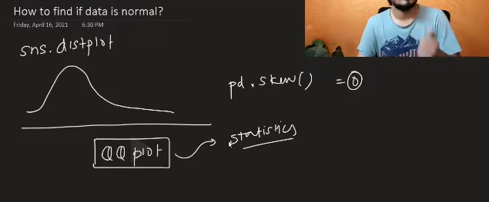
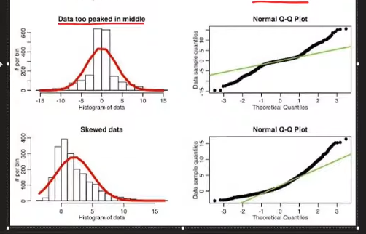

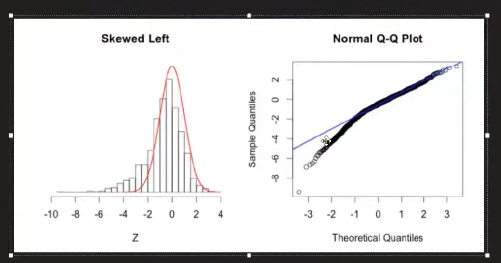
Log transform - This is used for the sake of converting each of the points towards normal distribution, it will not happens directly, but will introduce a little bit of the normality.
This is to be applied on the right skewed.

If the data distribtuion is too big and it too much scaled, then by taking the log will make everything into the proper scale.
Ex; log 10, will make everything to from 100 to 1000 to fall under 2 to 3,Since this is getting applied on every point of the data , it will be making the proper distribution to the model which demands this kind of the distributiion.

Since this look as if Normal and looks like linear(the scales, 2-3, 3-4), these things hence makes the linear based models to work greatly. Ex: Linear regression, logistic regression.
The one which are too far will be looking like linearly distributed.

Hence we use the log transform.
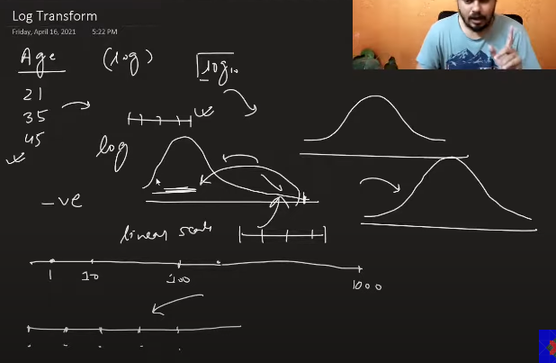
This works for the right skewed.

Before making the transformation there should be 0 none values.

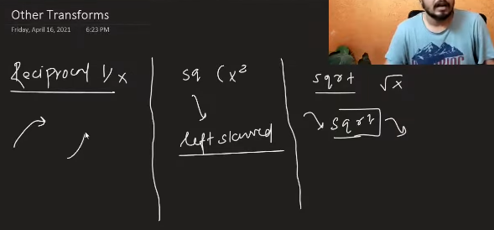

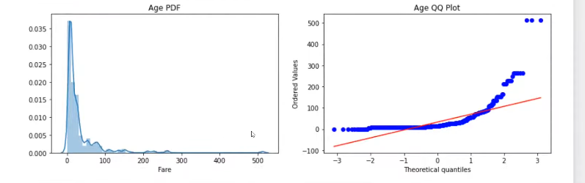
This is right skewed, so we can perform log transformation.

This is before applying the transformation.
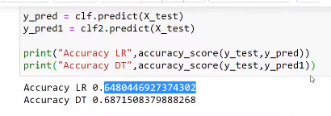
This is after applying the transformation, I got this output. Some algorithms for which scling will not affect.
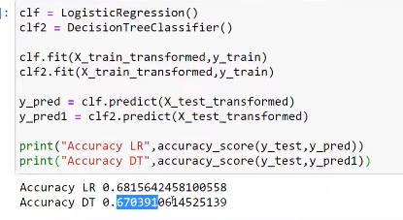

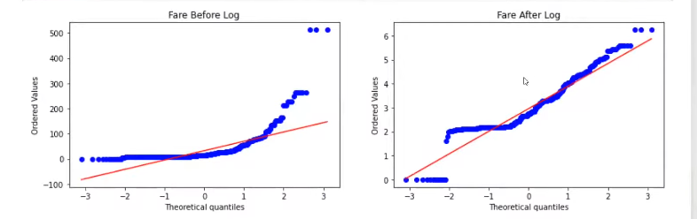

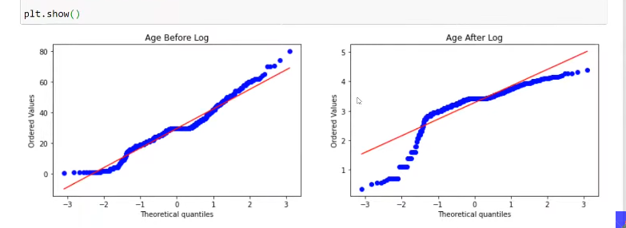
Now applying the log transformation only on the fare, since the age column is not making the perfect normal distribution. Which helps a bit.

The way the data is distributed, makes a greater appeal for the Linear regression and logistic regression not for the other distribution.

There are many mathematical transformations are available , you should try all those and chck whether the results are getting good or not.

POWER TRANSFORMERS

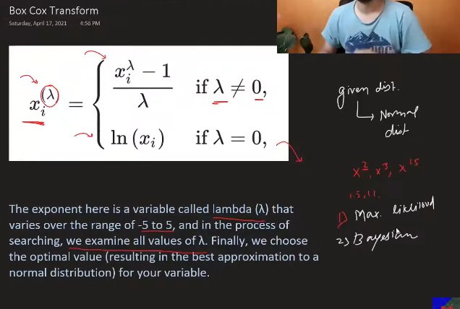
Box cox works only for those numbers which are greater than 0. Not to =0, <0, but only to those numbers which are greater than 0.
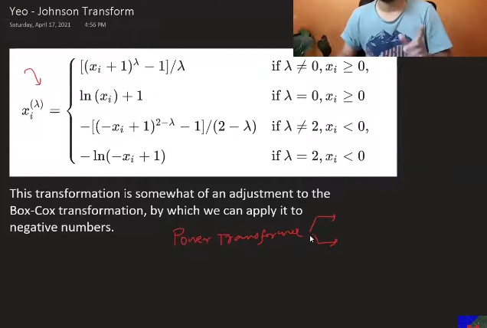
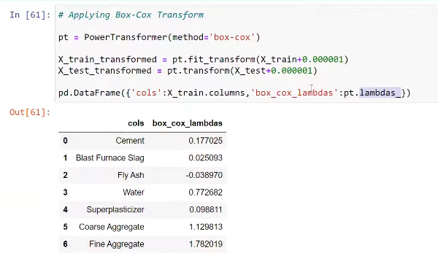

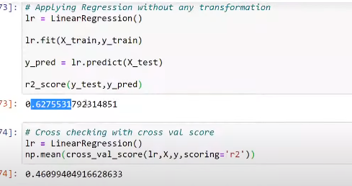

After transformations:
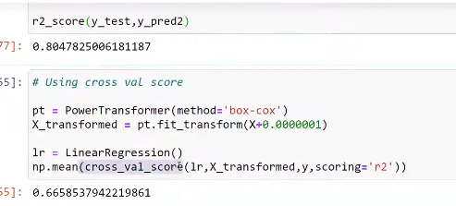

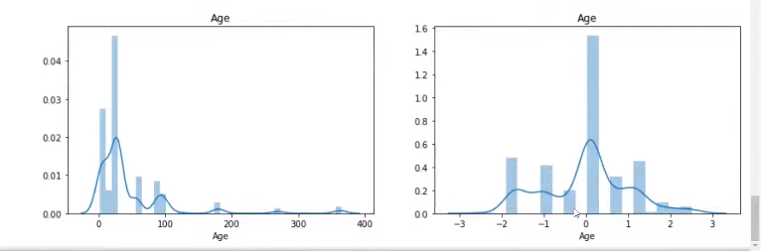
Yoe-Jhonson
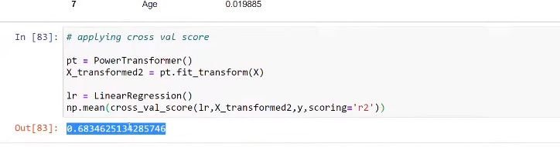

ENCODING NUMERICAL FEATURES
This method is uded for converting the continuos values to the many bins.
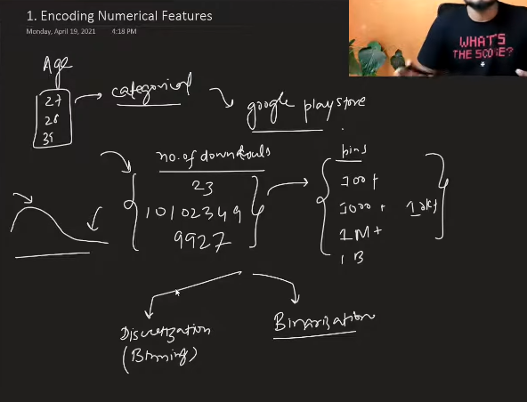

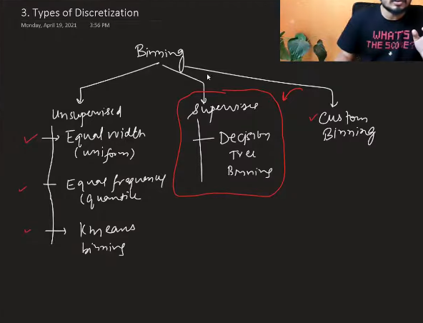

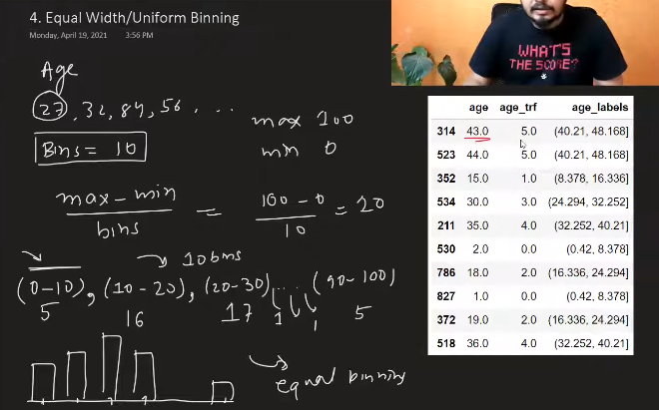
In this if you have 100 metrics, you need to divide the whole bins by 10, then it will check between 0-9, how wha is the frequnecy ,and from the 10-19 what is the frequency this frequency keeps on changing, based on the number of people or row belonging to that category.

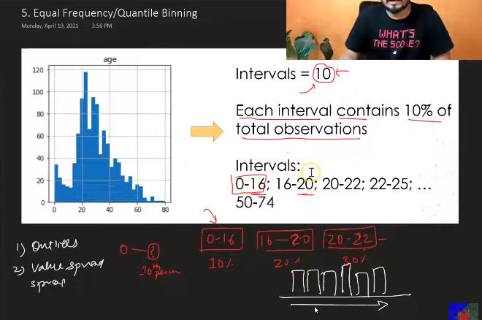
You need to give the number of bins you need, based on this , it will make the binning based on the percentile. Suppose 10 has been given, for 100, then first 10ile is present in which range. The 2nd 10ile present in whcih bin range and so on , this keeps calculated automatically then based on the above it makes the binning.
It makes the proper binning , automatically in a proper sequence. This is majorly used.
K-means Binning

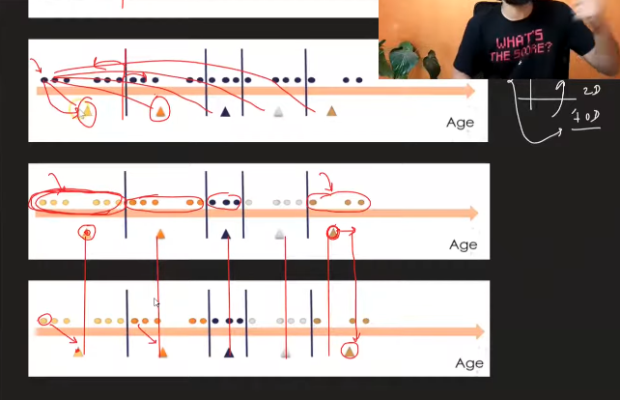
Implementation: KBinsDiscretizer in sklearn. Go and learn the document properly .

BINARISATION

Converting from the continous to the 2 classes. Only use threshold.

HANDLING MIXED DATA

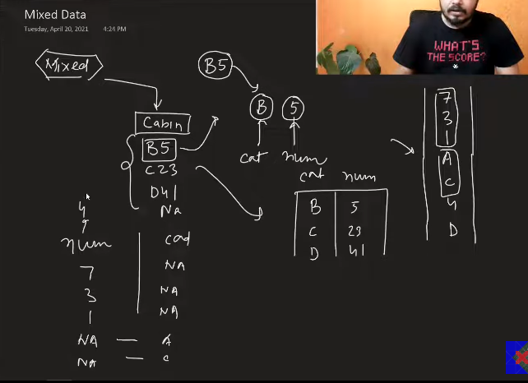

pd.to_numeric -, pd.to_datetime.

HANDLING MISSING DATA

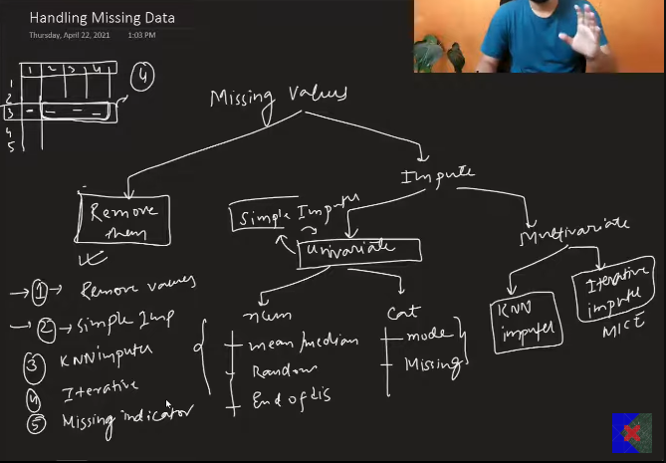
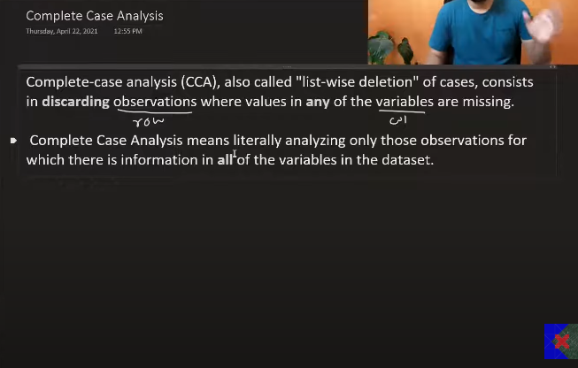

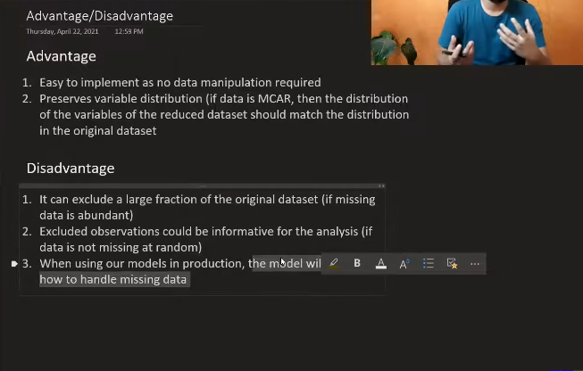

When to use this?
- This should b used when the data is missing completley at random.
- If the data that is missing is less than or eual to 5% only then we will use this else we ill not.

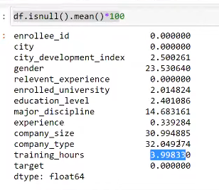
Hint :
- if the column is numerical, then apply the cca and check the before results and after results, if both are comparable in the distributon then we have done properly, else not.
- For the actegor based data: check what is the distribution for each category before CCA and after cca, fine to make the variations in within 5%, but not with too much.

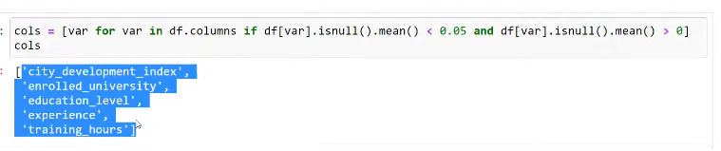
THis CCA is not useful at the time of deployment, because it cannot handle anything if missed at the time of deploying.

To drop null you have to use this: df_cleaned = df.dropna()

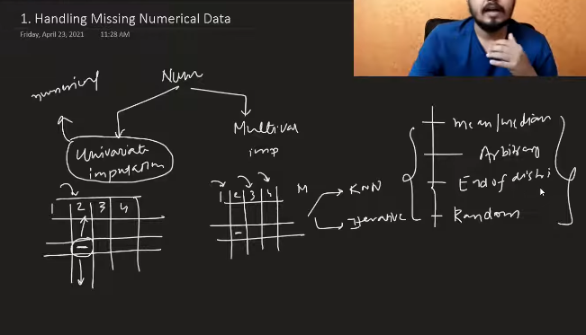

When the data is little bit skewed, then it is better to use median not mean for imputation.

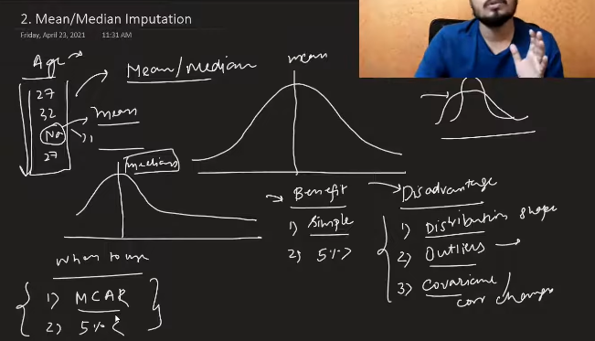
If you replace all the things with the mean or median , that means you are shifiting eveythong towards mean , hence the varance will reduce.
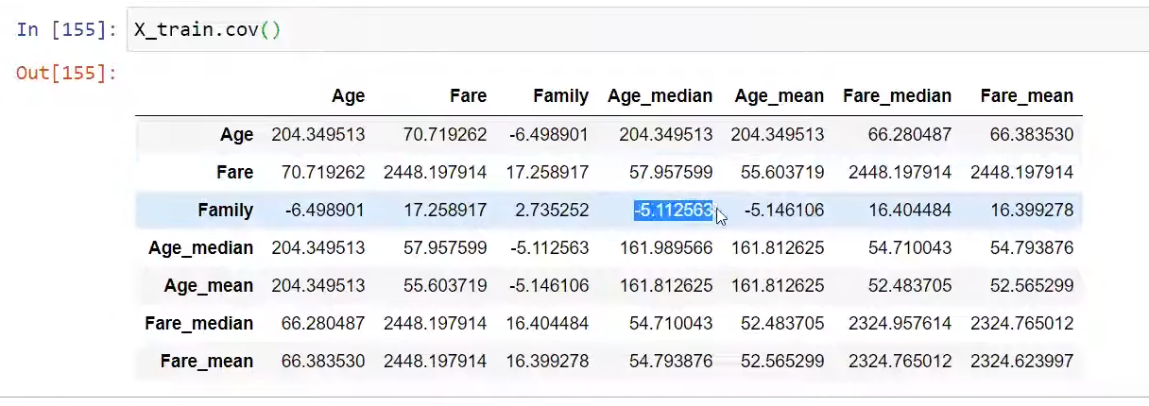

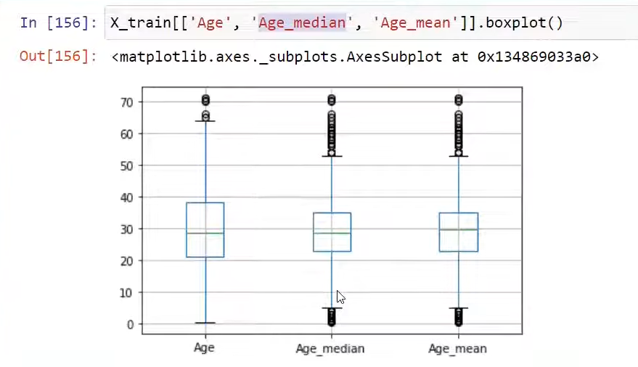

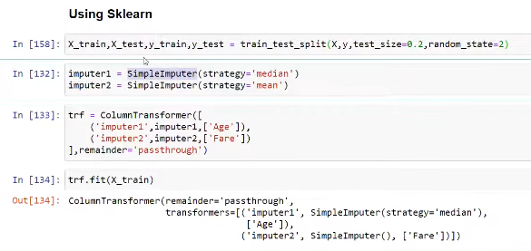

In this e should not make any imputation of the age with mean or median , bcause will increase the outliers in the data, hence it is better to keep it away from mean or median.
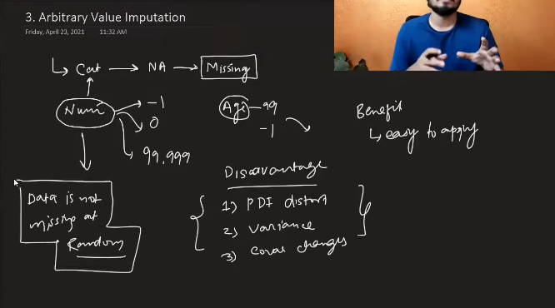
Usually this is not used many times. The missing data should be continuos by the way.

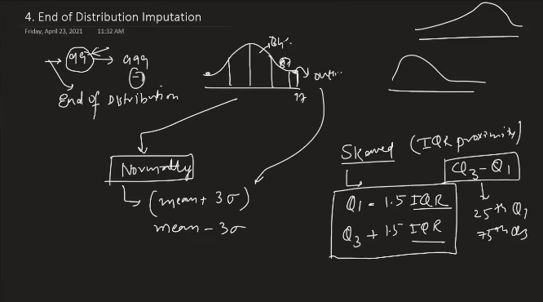
To apply this , it must be numrerical data.

HANDLING CATEGORICAL MISSING DATA

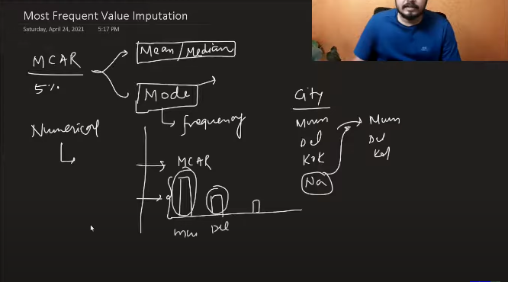
When the data is present in random you an apply thee kind of things.

When you are replacing the missed by null values then it has to have one dominant category compared to others.
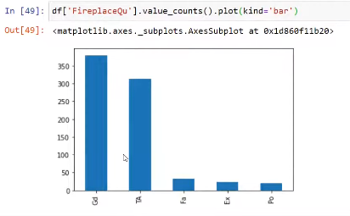
Like this it should not be there, only one column should dominate not others.
Results will not that good to make the difference.

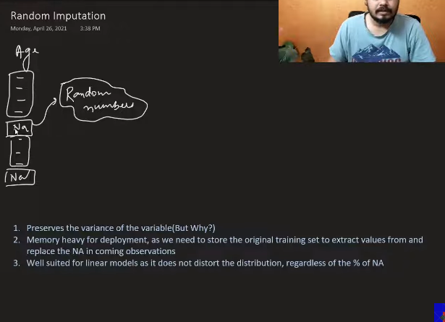
Select the randonmly random number among the numbers that are available from the previous numbers in the column.
Using the data distribution remains almost the same. When we are dealing with the linear methods, it works greatly .
The covariance changes, outlier will not chnage
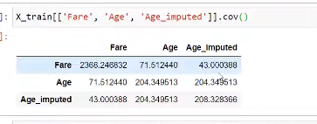
The random state has to be fixed with theb above code, else there is big chance thta will over rule , if a person entering the same entry twice it will result in the differnt answers for the same entry.
Use this.

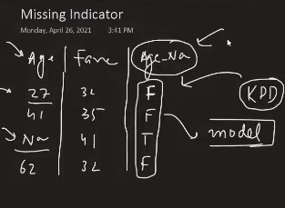
This kind of data tell the ML model, please have a look into it , there is difference in the values. So treat the things differently, these all the things to be taken care.
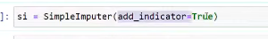

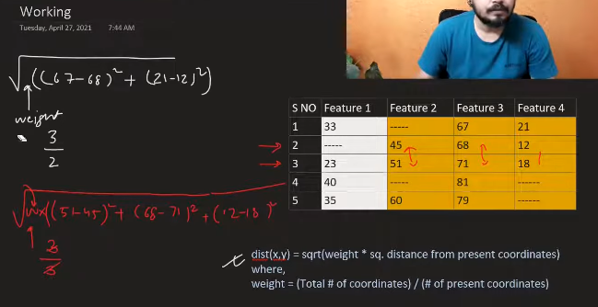

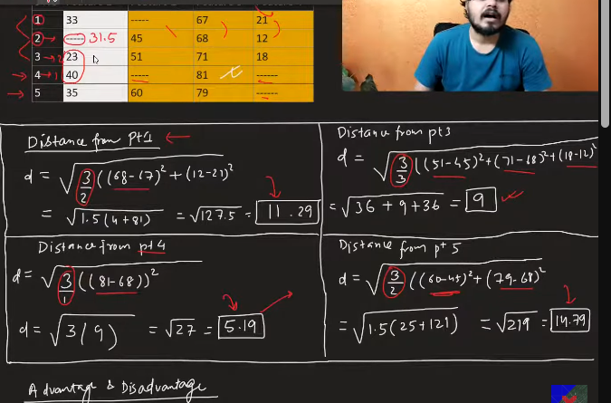

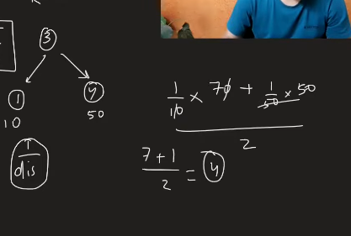
This is based on the distance

2 disadvantages:
- Time consuming
- Deployment time, we need to give the whole data.

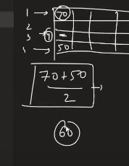
This is uniform

This KNN imputer performs great over other imputers.

ITERATIVE IMPUTATION(MICE)

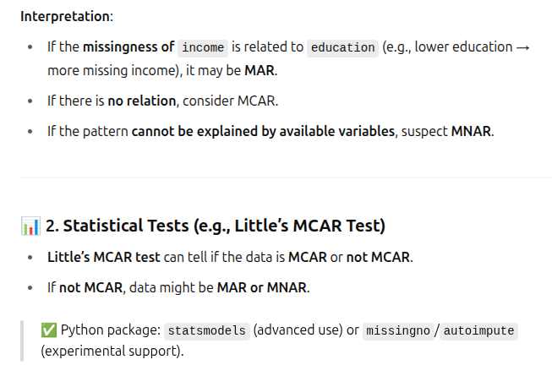
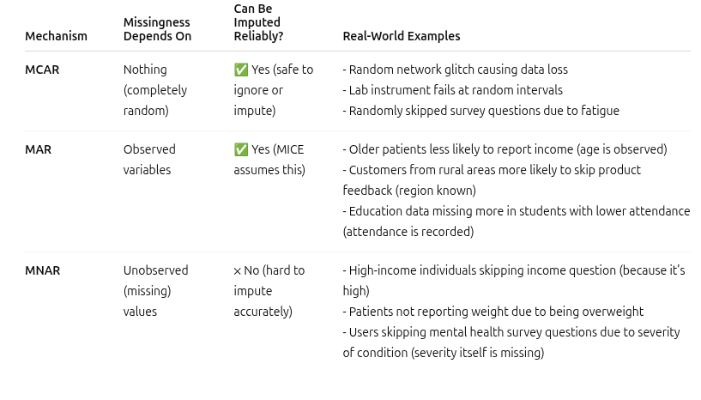
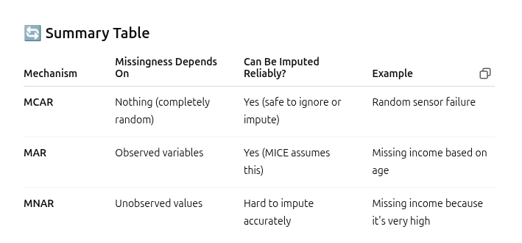

MICE algorithm

This works well on the MAR
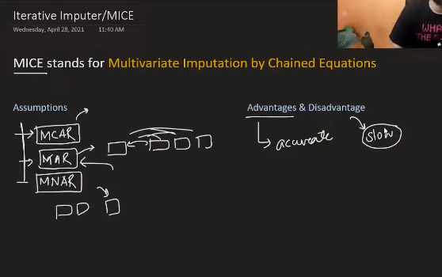

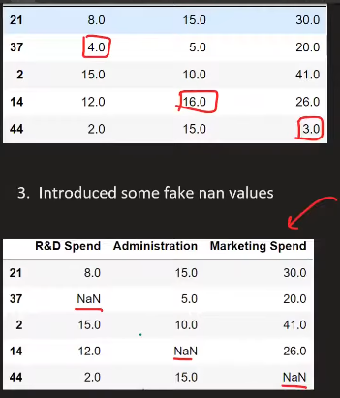
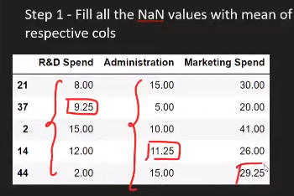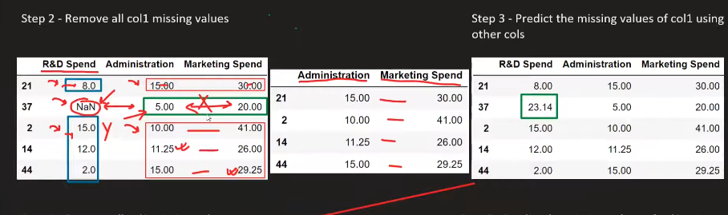
The one entry which is missing becomes the Y, leaving that, rest every row will act as the input for training data, apply any ML algo to predict the missing value.

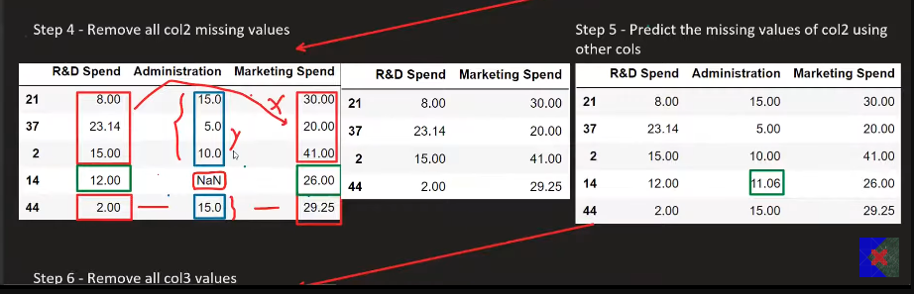
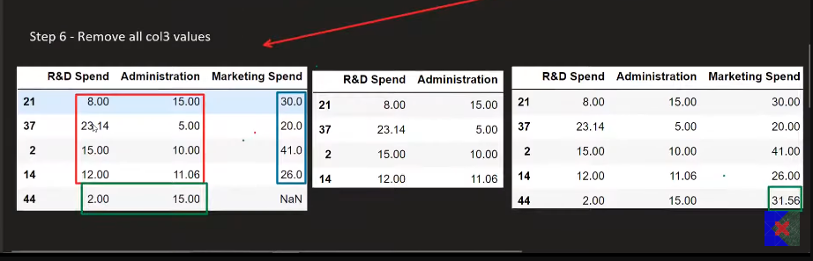

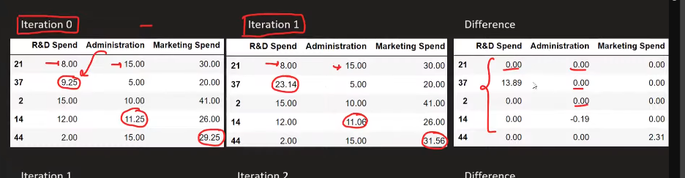
This iterations to be done till it makes the output 0.
